
CRC Block
Cyclic Redundancy Check
CONTENT
CRC Hardware Block Specification 2
1. Overview 2
2. Block Diagram 2
3. Interface Specification 3
4. Functional Description 4
4.1 CRC Calculation 4
4.2 CRC Polynomial Options 4
4.3 CRC Calculation Algorithm 4
4.4 Output Handling 5
5. Operational Modes 6
5.1 Single Calculation Mode 6
5.2 Continuous Calculation Mode 6
6. Timing Specifications 6

CRC Hardware Block Specification

1. Overview
This specification defines a Cyclic Redundancy Check (CRC) hardware block capable of computing CRC checksums for data with a width of 32 bits. The block supports multiple CRC polynomial options: CRC-3, CRC-8, CRC-16, and CRC-32.

2. Block Diagram
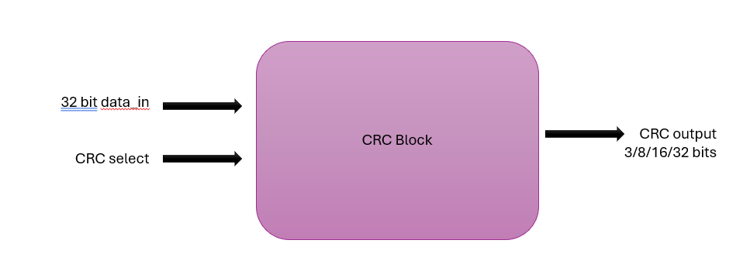

3. Interface Specification

Signal Name | Direction | Width | Description
clk | Input | 1 | System clock – 120MHz
rst_n | Input | 1 | Active low reset
data_in | Input | 32 | Input data for CRC calculation
data_valid | Input | 1 | Indicates valid data is present on data_in
crc_select | Input | 2 | Selects CRC polynomial (00:CRC-3, 01:CRC-8, 10:CRC-16, 11:CRC-32)
crc_init | Input | 32 | Initial value for CRC calculation
crc_out | Output | 32 | CRC calculation result (width depends on selected CRC)
crc_valid | Output | 1 | Indicates valid CRC result is available
busy | Output | 1 | Indicates the block is processing

4. Functional Description

4.1 CRC Calculation
The CRC block calculates a checksum based on the input data and the selected CRC polynomial. The calculation follows the standard CRC algorithm with the following steps:
- Initialize the CRC register with the value from crc_init
- Process the 32-bit input data
- Output the final CRC value

4.2 CRC Polynomial Options
CRC Type | Width | Standard Polynomial | Hexadecimal Representation
CRC-3 | 3 | x³ + x + 1 | 0x3
CRC-8 | 8 | x⁸ + x² + x + 1 | 0x107
CRC-16 | 16 | x¹⁶ + x¹⁵ + x² + 1 | 0x18005
CRC-32 | 32 | x³² + x²⁶ + x²³ + x²² + x¹⁶ + x¹² + x¹¹ + x¹⁰ + x⁸ + x⁷ + x⁵ + x⁴ + x² + x + 1 | 0x104C11DB7

4.3 CRC Calculation Algorithm

4.3.1 Mathematical Foundation
A CRC is calculated by treating the input data as a polynomial over GF(2) (binary Galois Field) and performing polynomial division by the CRC generator polynomial. The remainder of this division is the CRC value.

4.3.2 Detailed Algorithm
For a 32-bit data input and the selected CRC polynomial, the calculation proceeds as follows:
(This guidance is for a single bit. Have to implement it * 32 bits: )
- Initialization: Load the CRC register with the initial value (crc_init)
- Data Processing: For each bit of the 32-bit input data, starting from the most significant bit (MSB):
XOR the MSB of the current CRC register value with the current data bit
If the result is 1:
  - Shift the CRC register left by 1 bit
  - XOR the CRC register with the CRC polynomial
If the result is 0:
  - Shift the CRC register left by 1 bit
- Finalization: The final value in the CRC register is the CRC checksum

4.3.3 Hardware Implementation Approaches
The hardware block supports parallel processing implementation method:
- Bit-by-Bit Processing:
  - Process one bit at a time as described in the algorithm above
  - Simple but requires 32 clock cycles for a 32-bit input
- Parallel Processing:
  - Process multiple bits in parallel using combinational logic
  - For 32-bit data, implement a 32-stage linear feedback shift register (LFSR)
  - Achieves single-cycle CRC calculation for the entire 32-bit input
  - Most efficient for this application

4.3.4 Parallel CRC Calculation
For the 32-bit parallel implementation:
- Express the CRC calculation as a matrix multiplication in GF(2)
- Pre-compute the transformation matrix based on the CRC polynomial
- Implement the matrix multiplication as a network of XOR gates
- The result is computed in a single clock cycle
The mathematical representation for parallel CRC calculation:
CRC_next = (CRC_current << 1) ^ (MSB(CRC_current) ? CRC_polynomial : 0)
For a 32-bit parallel implementation, this operation is expanded to process all 32 bits simultaneously through a network of XOR gates derived from the polynomial.

4.4 Output Handling
- For CRC-3: Only the 3 least significant bits of crc_out are valid
- For CRC-8: Only the 8 least significant bits of crc_out are valid
- For CRC-16: Only the 16 least significant bits of crc_out are valid
- For CRC-32: All 32 bits of crc_out are valid

5. Operational Modes

5.1 Single Calculation Mode
- Set crc_select to the desired CRC type
- Set crc_init to the desired initial value
- Assert data_valid with valid data on data_in
- Wait for crc_valid to be asserted
- Read the result from crc_out

5.2 Continuous Calculation Mode
For processing multiple data blocks with the same CRC:
- Set crc_select to the desired CRC type
- Set crc_init to the desired initial value for the first block
- Assert data_valid with valid data on data_in
- Wait for crc_valid to be asserted
- Read the intermediate result from crc_out
- For subsequent blocks, set crc_init to the previous crc_out value
- Repeat steps 3-6 for each data block

6. Timing Specifications
Parameter | Description | Value
t_setup | Setup time for all inputs before clock edge | 2 ns
t_hold | Hold time for all inputs after clock edge | 1 ns
t_clk_to_out | Clock to output delay | 3 ns
t_calculation | Maximum calculation time | 2 cycles

